Q-215B线性阵列音箱
特点:
Q系列音箱采用大功率单元和精密设计的箱体，配合一体成型的线阵号角，使音箱具有高灵敏度，大动态，高声压级的特点。它同时还具备简单、安全的搬运装置以及快速搭建和拆卸系统，适用于体育场馆，礼堂，多功能厅，流动演出等需要高质量音响系统的场合。
Features and application:
By adopting high power drivers and precise design coordinated with integratedformation linearraybugle, the speakers feature high sensitivity, high mobility, and high SPL. Thanks to the safe transporting facilities and quick installment and dismantle system, they are ideal for using in stadiums, stages, multi-function halls, auditorium, and other flow performance sites where high quality sound systemwere desired.

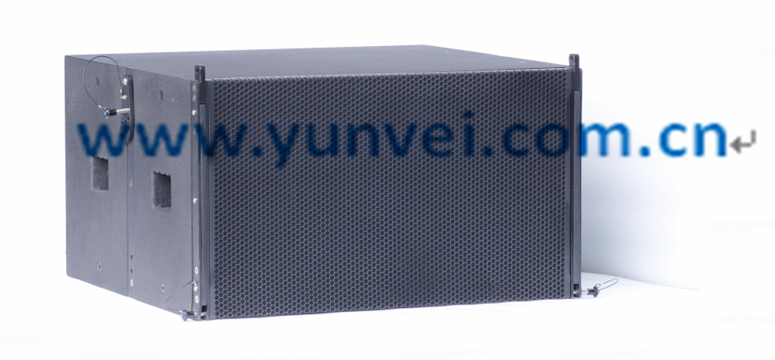
Q-215B
特点及应用:
* 2 x 15"低频驱动器
*简单安全的吊挂件
*快速的落地或吊挂安装
*人体工程学把手的设置
*采用防水防撞的金钢沙防水涂层
*多层桦木夹板
*加硬的金属铁网，声学透气网棉
*适用于体育场馆，礼堂，多功能厅，大中型流动演出
Features and application:
*2x15”Ultra-LF driver
*Simple suspension devices
*Quicksuspension and mounting
*Ergonomic knob
*Waterproof and bump proofcorundum coating
*Multi-layer birch ply
*Enhanced steel grill, acoustic ventilation filter screen
*Suitable for using in stadium, stage, multi-function hall, auditorium,large and medium-sized movable performance venues.

产品参数Qarameters:
单元组成Driver：LF2x 15"
标称阻抗Nominal Impedance:LF4Ω
额定功率 Power Handling: LF1000W
频率响应 Frequency Range (+/-3 dB):40 Hz - 280Hz
灵敏度 Sensitivity: LF 101dB
最大声压级：Maximum Peak SPL:LF 134 dB
连接插座Connection:2xSpeakon NL4
音箱尺寸Product dimensions:(WxDxH)800x750x450mm
净重N.W : 48KG
