**YUNVEI BW系列音箱**

**特点：**

此系列采用了最新的定制单元，保持了效率高，音质好的两大亮点，低音采用了FLX技术，保证质量的同时又大大的提升了单元效率，高音单元同样采用了进口膜片的设计，确保了整个音箱拥有更宽的频率响应。

适合大中小型会议室、多功能厅、展厅、流动扩声等。

Features:

This series adopts the latest custom-made unit, which maintains two high-efficiency and high-quality sounds. The bass uses FLX technology to ensure the quality and greatly improve the unit efficiency. The tweeter also adopts the imported diaphragm design. This ensures that the entire speaker has a wider frequency response.

Suitable for large, medium and small conference rooms, multi-purpose halls, exhibition halls, mobile sound reinforcement, etc.

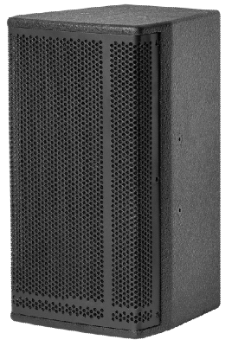**BW-508**

单元组成Driver:LF1x 8" HF1x 1.25"

标称阻抗 Nominal Impedance:8Ω

额定功率 Power Handling:150W

频率响应 Frequency Range (+/-3 dB): 75Hz -18kHz

辐射角度 Dispersion(-6 dB): H x V90°x 60°

灵敏度 Sensitivity:93dB

最大声压级：Maximum Peak SPL:117dB

连接插座：Connection:2x Speakon NL4

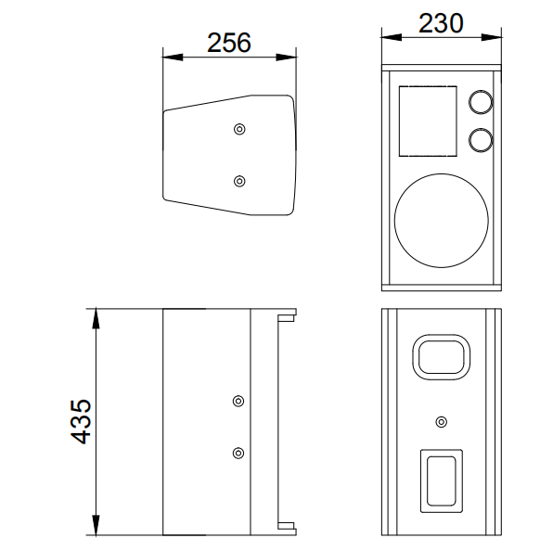音箱尺寸Product dimensions(WxDxH):230x256x435mm

净重N.W:8.5KG