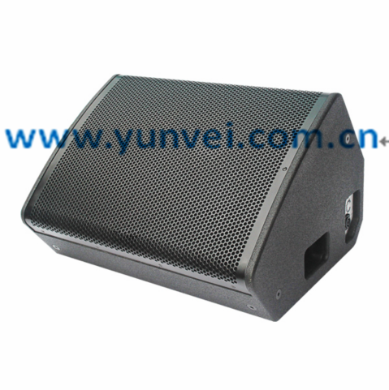
EC-15M返听音箱
EC-15M returns to the speaker
特点:
两分频高性能舞台返听扬声器,45° x 60°的恒定指向性,提供高还原度且大范围的直达声,非凡的还原性，清晰自然平衡的声音 ,箱体结构是用桦木夹板制成,装有一对人工力学把手,表面喷涂金刚砂防撞水性漆 ,采用圆孔高强度铁网,在箱体两侧边固定装有非常便于快速灵活的安装吊挂
适用演艺大厅、现场表演、多功能厅、报告厅、宴会厅等场所
Features:
Two divider high performance stage back hearing loudspeaker.Constant directivity of 45 degree x 60 degrees.Provide high reduction and wide range of direct sound.A remarkable reductive, clear and balanced sound.The box structure is made of birch splints.Equipped with a pair of manual mechanical handles.Surface spraying of emery against water-based lacquer.High strength iron net with circular hole.Fixed on both sides of the box is a very convenient, quick and flexible installation.Application hall, scene performance, multi-function hall, banquet hall and other places.
EC-15M
产品参数Parameters:
单元组成Driver：LF1x 15" HF1x 1.75"
标称阻抗 Nominal Impedance: 8Ω
额定功率 Power Handling: 500W
频率响应 Frequency Range (+/-3 dB): 50Hz -18kHz
辐射角度 Dispersion(-6 dB): H x V45°x 60°
灵敏度 Sensitivity :98dB
最大声压级Maximum Peak SPL: 128dB
连接插座Connection:2x Speakon NL4
音箱尺寸Product dimensions(WxDxH):740x449x483mm
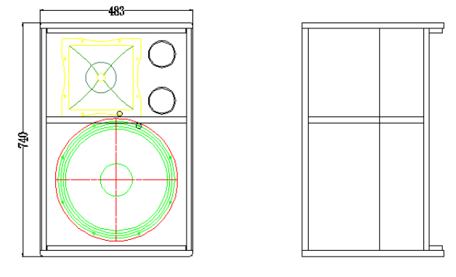
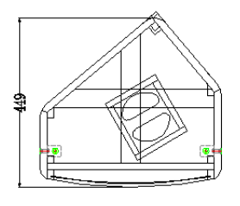
净重N.W:38KG

