Badao9000娱乐音箱

特点：
1.独特合成材料纸盆，有效提高了话筒的柔顺性和稳定性
2.高品质滤波元件和卓越的无源滤波技术。
3.恒指向高音90º×60º，可根据实际使用场所旋转。
4.完善的吊装结构和安装点位设计，底部带支撑插孔。
适用于娱乐会所和DISCO，慢摇吧及豪华娱乐包房，演艺大厅、现场表演、酒吧，多功能厅、宴会厅
1. Unique synthetic material paper cone, which effectively improves the flexibility and stability of the microphone
2. High quality filter components and excellent passive filtering technology.
3. Constant pointing treble 90o × 60o, can be rotated according to the actual use.
4. Perfect lifting structure and installation point design, with support socket at the bottom.
Suitable for entertainment clubs and DISCO, slow rocking and luxury entertainment rooms, performing arts halls, live performances, bars, multi-purpose halls, banquet halls
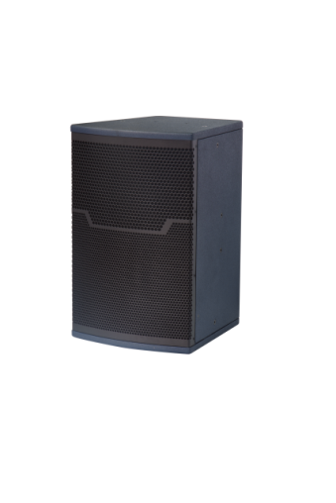
Badado9000
产品参数Parameters:
单元组成Driver：LF1x 15" HF1x 3"(75ф) Exit Compression Driver
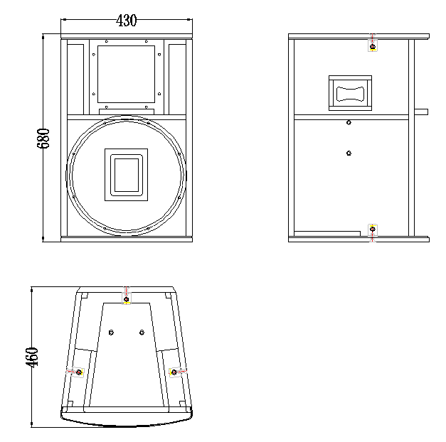
标称阻抗 Nominal Impedance: 8Ω
额定功率 Power Handling: 800W
频率响应 Frequency Range (+/-3 dB):40Hz -18kHz
辐射角度 Dispersion(-6 dB): H x V 90°x 60°
灵敏度 Sensitivity: 99dB
最大声压级：Maximum Peak SPL: 132dB
连接插座Connection:2x Speakon NL4
音箱尺寸Product dimensions(WxDxH):430x460x680mm
净重N.W:43.5KG

