YUNVEI SK-10系列音箱规格参数
特点：
此系列音箱具备的灵敏度，频率响应和功率，适用于大多专业音频环境
多个吊点保证了音箱可以多角度使用
高品质单元的选用保证了大声压级状态下声音不失真
精确的分频调教使得语言清晰易懂，饱满自然
厅堂扩声系统主扩声,大会议厅，多功能厅,台唇补声，酒店，现场演出等
Features:
The sensitivity, frequency response and power of this series of speakers are suitable for most professional audio environments.
Multiple lifting points ensure that the speaker can be used at multiple angles
The selection of high-quality units ensures that the sound is not distorted in the state of loud sound pressure.
Accurate crossover tuning makes the language clear and understandable, full of nature
Hall sound reinforcement system main sound reinforcement, large conference hall, multi-function hall, table lip fill sound, hotel, live performance, etc.
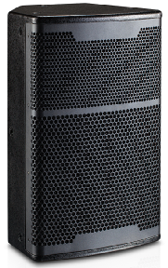
SK-10
产品参数Parameters：

单元组成Driver:LF1x 10" HF1x 1.25"
标称阻抗 Nominal Impedance: 8Ω
额定功率 Power Handling :200W
频率响应 Frequency Range (+/-3 dB):70Hz -20kHz
辐射角度 Dispersion(-6 dB): H x V 80°x 50°
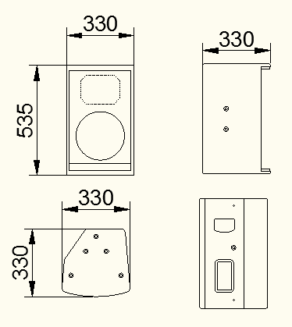
灵敏度 Sensitivity :95dB
最大声压级Maximum Peak SPL:121dB
连接插座Connection2:x Speakon NL4
音箱尺寸Product dimensions(WxDxH):330x330x535mm
净重N.W:16KG

