SA8 8路调音台8-channel mixer
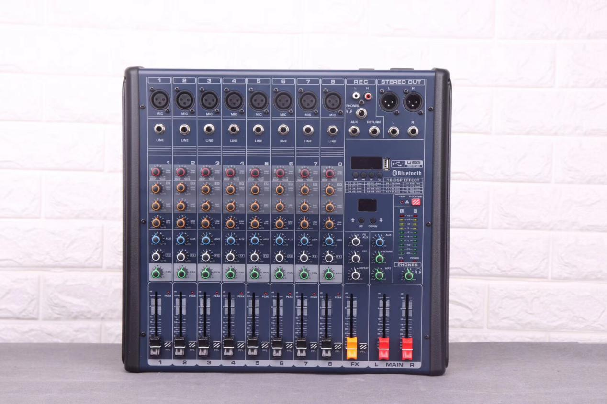
•1-8路麦克风单声道输入
•每路均设有三段均衡，独立监听开关
•双10段三色电平指示
•内置双七段立体声主控均衡器
•内置数字显示16种DSP混响效果器，进口芯片
•每一路独立设有48伏电源按钮
•内置带蓝牙、带录音，歌词显示USB播放器
•尺寸L×W×H(长宽高)：39.5×37.5×9CM
•1-8 microphone mono input
• Three equalizations for each channel, independent monitor switch
• Dual 10-segment three-color level indication
• Built-in dual seven-segment stereo master equalizer
• Built-in digital display 16 kinds of DSP reverb effects, imported chips
• 48 volt power button for each channel
• Built-in with Bluetooth, with recording, lyrics display USB player
• Size L × W × H (length, width and height): 39.5 × 37.5 × 9CM

综合参数Comprehensive parameter: Verall system
•谐波失真Thd/+N：≦0.1% •Harmonic Distortion:≦0.1%
•频率响应Frequency Range：20Hz-20KHz •Frequency Response:20Hz-20KHz
•信噪比Signal-to-noise Ratio：≧-80dB •S/N Ratio:≧-80dB
•输出Output：11V Max •Max Outputs:11V Max
•输入灵敏度Input sensitivity： •Input Sensitivity:
Mic:-60dB Line in:-40dB Mic:-60dB Line in:-40dB
Efret in:-40dB Aux in:-40dB Efret in:-40dB Aux in:-40dB
Tape in:-40dB Tape in:-40dB
•输入均衡Input equalization： •Parametric EQ:
HI:±15dB/10KHz HI:±15dB/10KHz
MID:±15dB/2.5KHz MID:±15dB/2.5KHz
LOW:±15dB/80Hz LOW:±15dB/80Hz

