HP-2600数字音频处理器DIGITAL SPEAKER PROCESSOR

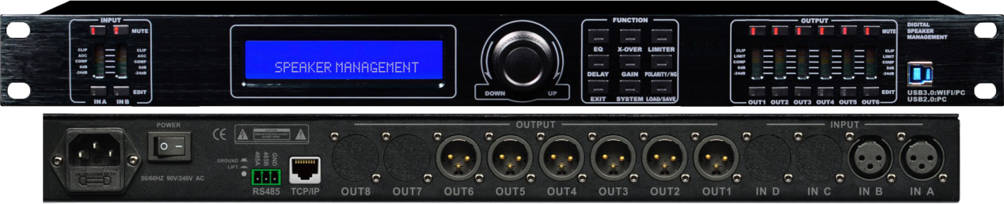

产品特点：
1、96KHz采样频率，32-bit DSP处理器，24-bit A/D及D/A转换；
2、2路信号输入6路信号输出，，可灵活组合多种分频模式，高、低通分频点均可达20Hz～20KHz；
3、提供USB和RS485接口可连接电脑，通过RS485接口可最多连接250台机器和超过1500米的距离外用电脑来控制；
4、直接用面板的功能键和拔轮进行功能设置或是连接电脑通过PC控制软件来控制，均十分方便、直观和简洁 ；
5、单机可存储30种用户程序，可通过面板的SYSTEM按键来设定密码锁定面板控制功能，以防止闲杂人员的操作破坏机器的工作状态；
6、每个输入和输出均有6段独立的参量均衡，调节增益范围可达±20dB，同时输出通道的均衡还可选择Lo-shelf和Hi-shelf两种斜坡方式；
7、2×24 LCD蓝色背光显示功能设置，6段LED显示输入/输出的精确数字电平表、哑音及编辑状态；
8、每个输入和输出均有延时和相位控制及哑音设置，延时最长可达1000ms，延时单位可选择毫秒(ms)、米(m)、英尺(ft)三种 ；
9、输出通道还可控制增益、压限及选择输入通道信号，并能将某通道的所有参数复制到另外一个通道并能进行联动控制；
10、可以通过USB接口或RS485接口连接中控来控制矩阵和通道的哑音，可以分功能锁定，实现数据保密，输入通道可调噪声门；
11、可通过WIFI连接电脑。

1、96KHz sampling frequency, 32-bit DSP processor, 24-bit A/D and D/A conversion；
2、2-channel signal input 6-channel signal output, flexible combination of multiple frequency division modes, high-pass and low-pass crossover points up to 20Hz~20KHz；
3、Provide USB and RS485 interface to connect to the computer, connect up to 250 machines and external computers over 1500 meters through RS485 interface for control;
4、It is very convenient, intuitive and concise to directly use the function key setting function of the panel and the puller or connect the computer control through the PC control software.
5、Independently store 30 user programs，The password lock panel control function can be set through the SYSTEM button of the panel to prevent the operation of the idler from damaging the working state of the machine.
6、Each input and output has 6 independent parameter equalizations, the gain range can be adjusted to ±20dB, and the output channel equalization can also be selected for low and elevated ramp modes.
7、2×24 LCD blue backlight display function setting, 6-segment LED display input/output accurate digital level meter, mute and editing status；
8、Each input and output has a delay and phase control as well as a mute setting. The delay can be up to 1000ms. The delay unit can be selected in milliseconds (ms), meters (m), and feet (ft).
9、The output channel also controls gain, voltage limit and select input channel signals, and can copy all parameters of one channel to another and perform connection control.
10、The central controller can be connected via USB or RS485 interface to control the maturation of the matrix and channel.
11、Data lockability can be achieved through function locking，Input channel adjustable noise gate
12、Connect to computer via WIFI。

