**HF-1数字反馈抑制器Digital feedback Suppressor**

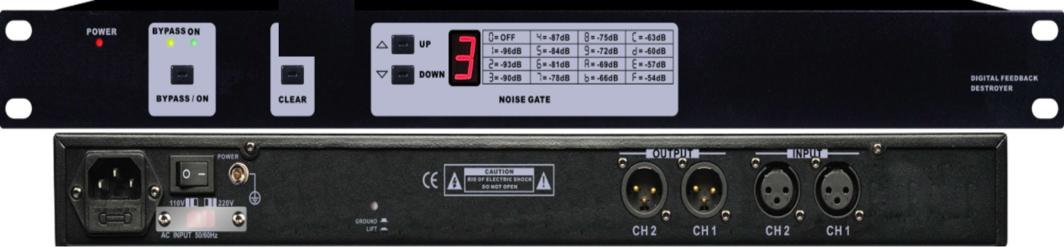

产品特点：

独立24个滤波器每通道，自动抑制啸叫点，超高信噪比，。带噪声门调节， 96KHz采样频率，32-bitDSP处理器，24-bitA/D及D/A转换，可通过面板的bypass/on按键切换工作模式为直通或抑制，可一键清除滤波器设置。

Independent 24 filters per channel, automatically suppress the howling point. Very high signal to noise ratio. With noise door adjustment.

96KHz sampling frequency, 32-bit DSP processor, 24-bit A/D and D/A conversion

The working mode can be switched to pass or suppress through the bypass/on button of the panel.

One-button clear filter settings