YUNVEI H-231
图示均衡器 EQUALIZER
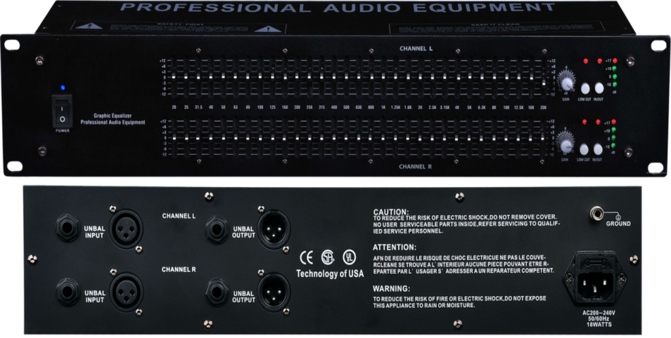

产品特点：
图示双31段恒定Q值均衡器，1/3倍频程
25mm行程的提升衰减推子,提供±12dB 的输入增益调节范围
全SMT表面贴装工艺
双7段光柱电平
1/4"的 TRS 输入连接器，为静音操作提供平衡输入和输出。
高切及低切开关功能，切点频率可调
Dual 31-segment constant Q equalizer, 1/3 octave
25mm stroke boost fader with ±12dB input gain adjustment range
Full SMT surface mount process
Double 7-segment beam level
1/4" TRS input connector provides balanced input and output for silent operation.
High cut and low cut switch function, adjustable cut point frequency

