H-2P电源时序器
Power Timer
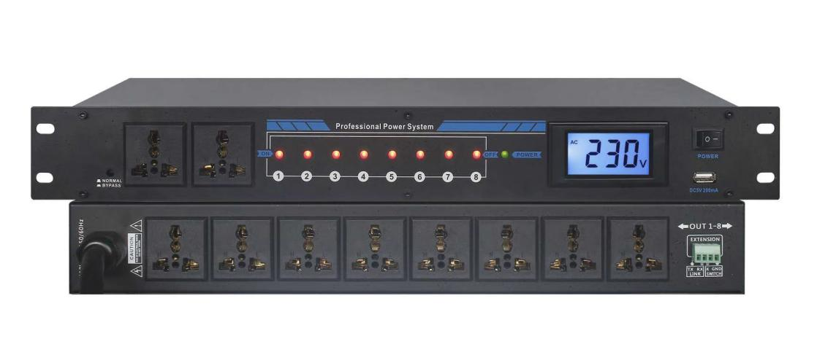

技术参数
●供电电源：交流 220V 50Hz 30A
●额定输出电压：交流 220V/50Hz
●继电器最大输出电流：AC250V/30A
●万能插座最大输出电流：AC250V/10A
●可控制电源：8路
●不可控制电源：2路
●每路动作延时时间：1秒
●每路输出带数字显示
●电源开关控制电源
●主电源线3*6平方电缆线
Parameters :
●Power supply: AC 220V 50Hz 30A
●Rated output voltage: AC 220V/50Hz
● Relay maximum output current: AC250V/30A
●Maximum output current of universal socket: AC250V/10A
● Controllable power supply: 8 channels
● Uncontrollable power supply: 2 way
● Each action delay time: 1 second
●Each output with digital display
●Power switch control power supply
●Main power line 3*6 square cable

